

G6 Internet Explorers

Great Teams

Create Great

Outcomes

**Prepared by:**

**Daria Sukonnova**

**Shane Thacker**

**Jeremy Naupay**

**Brian Dean**

**Submitted to RMIT**

**12 January 2020**

**Course Instructor:**

**Anthony Clapp**

Contents

Introduction 3

Team Profile 3

Team Name 3

Personal Information 3

Team Profile 5

Ideal Jobs 12

Tools 15

Industry Data 16

IT Work 18

IT Technologies 20

Cybersecurity 20

Machine Learning 23

Autonomous Vehicles 27

Natural Language processing and chatterbots 30

Project Ideas 33

G6 Internet Explorers Group Project 33

Group Reflection 34

References 37

# Introduction

This document seeks to explore various aspects of the I.T. Industry and team building synergies, showcasing the abilities of our extraordinary team members to participate effectively and creatively in group work and to analyse the human and social contexts of technological innovation. During this journey we have performed independent research, interviewed an I.T. Professional, collaborated on joint text, research, shared insights and learned a great deal about our strengths and integrity.

The members of the G6 Internet Explorers Team invite you to enjoy the following information.

# Team Profile

## Team Name

The Team name of G6 Internet Explorers was chosen to reflect our group numbers ie six and the fact that we would be using the internet to research our project. G6 also has connotations of an elite group such as the Group of Seven Organisation of Advanced Economies.

## Personal Information

The following paragraphs give a brief introduction of each of the members of the G6 Internet Explorers Team.

My name is Brian Dean and my RMIT student number is S3831349 and I am a member of the G6 Internet Explorers Team. I was born in Brisbane, though spent much of my working life in Sydney. My wife and I are now living on the northern beaches of Cairns in a little spot called Yorkeys Knob, with our twelve year old ginger rescue cat called "Pumpkin", who shares by birthday day and month. I enjoy reading, mainly sci fi fiction, cooking and a spot of gardening. Currently self employed as a technology consultant to the hospitality and tourism sector, having worked in that industry and software houses for many years. I am enrolled in this Bachelor of I.T. degree to fill in the many holes in my knowledge and for accreditation for all those years of doing.

My name is Daria Sukonnova, my RMIT student number is S3812576 and I am a member of the G6 Internet Explorers Team. I was born in the Russian city named Khabarovsk but then we moved to the Northern capital of Russia - St. Petersburg. I enjoy doing many things such as playing the piano or drawing. My biggest passion is reading books of any genre. My dream is to become an Artificial Intelligence Engineer. I find writing code quite enjoyable. My first program was a primitive game on Unity which was created with a tutorial. Since that time I really like solve code challenges on Python. Hope that in the near future I will develop the necessary skills to achieve my goal.

My name is Jeremy Naupay my RMIT student number is S3831039 and I am a member of the G6 Internet Explorers Team. I have grown up in the Sydney area since the day I was born. I love using my spare time to play around with different operating systems and brushing up on knowledge base. I have worked in I.T for over 2 years now as an IT Support Officer and looking forwards to be an Chief Information Officer in the future. Sometimes i do love to plan our model train sets as a hobby, but i also enjoy just playing video games and working on modding games in general.

My name is Shane Thacker, and my current home is Toowoomba Queensland. My RMIT student number is s3827970 and I am a member of the G6 Internet Explorers Team. Born in Adelaide, I moved to Queensland when I was eighteen, where I got a job in the furniture industry. By twenty, I was going back and forth to Indonesia to train the suppliers on how to sand, prepare, upholster, assemble, glaze and upholster furniture for the Australian company I was working for. At twenty-one, I made the permanent move to Indonesia working for that company then eventually by the time I was twenty-two started my own teak outdoor furniture company. After the 2008 global crisis wiped out my customers, then me off the map, I worked for a European company managing their properties in Indonesia. When those properties were sold off in 2015, I joined an international school and became the school director.

My main interests are barbeque low and slow and fishing, both of which involve knocking back a few cold beers. I have three kids the youngest being six and extremely naughty, most likely because he is too spoilt. Flight simulation is my main “do on own” hobby, but I rarely find time these days.

I am working towards a Bachelor of International Business where I hope to move into a management position of an international company within the next five years.

## Team Profile

In the section below we review the team composition based on the results of the Meyers Briggs personality test and several others. It is interesting to note that of the four members of the G6 Internet Explorers Team each have different Meyers Briggs types.

#### Meyers Briggs test

**Jeremy – INFJ (Introverted, iNtuitive, Feeling, Judging)**

**Daria – INFP (Introverted, iNtuitive, Feeling, Perceiving)**

**Brian – ENFP (Extraverted, iNtuitive, Feeling, Perceiving)**

**Shane – ESTJ (Extraverted, Sensing, Thinking, Judging)**

|  |  |  |
| --- | --- | --- |
| The description of Personality Types: | | |
| **INFJ**  **(The Advisor)**  People with an INFJ personality type tend to be determined, reserved, and altruistic in their behaviour. They are idealists and are passionate about making the world a better place. They enjoy close relationships with a few people, but usually prefer working alone. |  | **INFP**  **(The Empath)**  People with an INFP personality type tend to be reserved, idealistic, and adaptable in their behaviour. They are curious people, often lost in thought. They enjoy being by themselves or with small groups of people and prefer to listen to and contemplate the thoughts of those around them. |
| **ENFP**  **(The Encourager)**  People with an ENFP personality type tend to be energetic, adaptable, and inventive in their behaviour. They like to think up new, creative ideas and love sharing them with other people. They thrive in group settings and enjoy meeting new people. | | **ESTJ**  **(The Commander)**  People with an ESTJ personality type tend to be organized, loyal, and hard-working in their behaviour. They are good, law-abiding citizens with a desire to lead. They are very principled and thrive when they are helping and encouraging others to follow a set of beliefs and values. |

**Cognitive functions:**

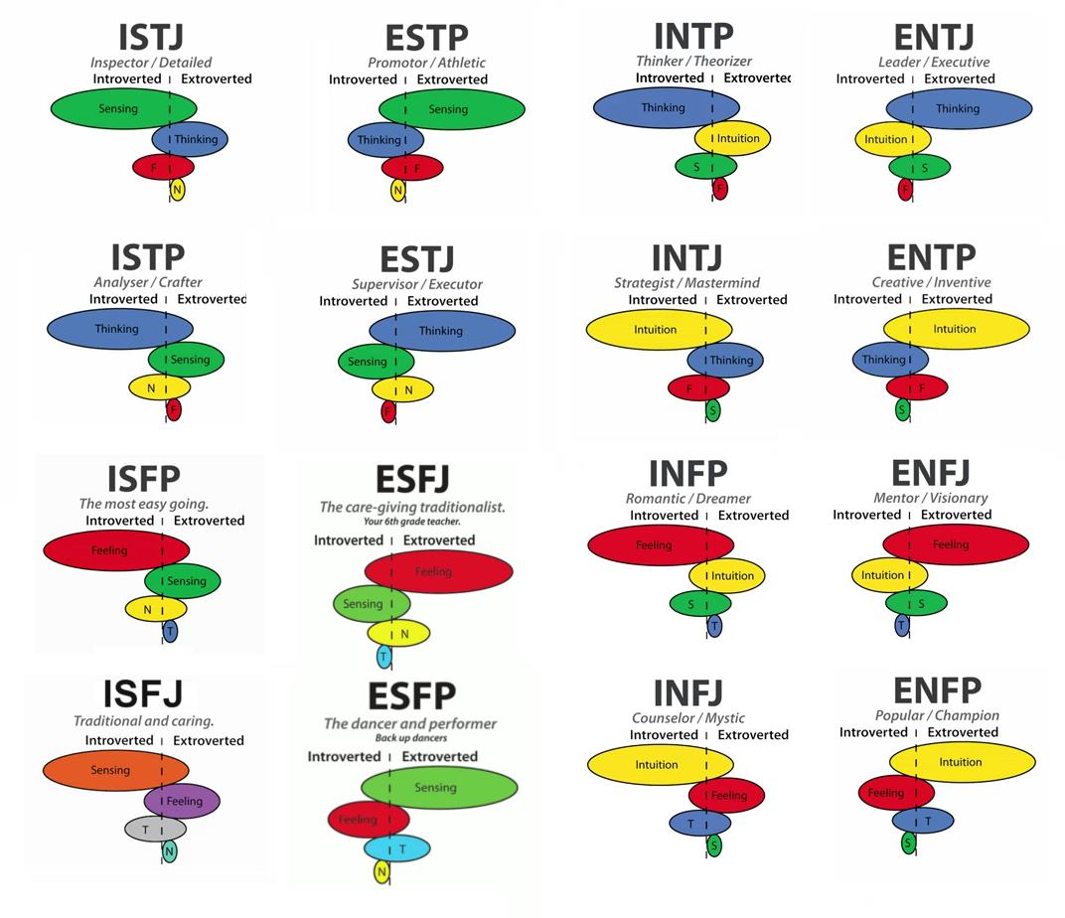

ESTJ – Shane

ENFP – Brian

INFJ – Jeremy

INFP – Daria

P

I

NF

E

J

ST

This diagram clearly shows how the personality traits of all group members intersect. Everyone got different test results, which means that we are of different personality types. For example, Shane and Daria have opposite results, so it is very important for them to learn to (?) understand each other's way of thinking and working. Jeremy and Brian, on the other hand, both have two similar letters - N(iNtuitive) and F(Feeling). They have some analogous traits such as tendency to process emotionally and focus their attention on the bigger picture. However, Jeremy is I(Introverted) and J(Judging) type, while Brian is E(Extroverted), P(Perceiving) type so they need to find an approach to each other's features.

|  |
| --- |
| How can these types communicate effectively with each other? |
| **INFJ&INFP (Jeremy, Daria):**  INFPs and INFJs tend to prefer time alone, process emotionally, and focus their attention on the bigger picture. However, INFPs are generally more flexible in their plans, while INFJs tend to follow schedules and processes. INFPs should be consistent around INFJs, while INFJs should give INFPs the freedom to move at their own pace. |
| **INFJ&ENFP (Jeremy, Brian):**  INFJs and ENFPs both tend to process emotionally and focus their attention on the bigger picture. However, INFJs tend to follow schedules and prefer to spend time alone or in small groups, while ENFPs are generally more flexible in their plans and thrive in larger group settings. INFJs should work to build personal connections with ENFPs, while ENFPs should allow INFJs space to recharge by communicating via email when necessary. |
| **INFJ&ESTJ (Jeremy, Shane):**  INFJs and ESTJs are very different; though they both prefer to follow a plan, INFJs are reserved, empathetic, and creative, while ESTJs are outgoing, logical, and present-focused. INFJs should work on expressing themselves more rationally around ESTJs. ESTJs should listen to and show empathy toward INFJs, allowing them space to be alone, when needed. |
| **INFP&ENFP (Daria, Brian):**  INFP and ENFP personalities both tend to focus on the overall perspective, consider the feelings of themselves and others, and prefer to follow flexible schedules. However, INFPs tend to be more reserved and ENFPs are generally outgoing. INFPs should feel open to share their feelings with ENFPs while ENFPs should respect INFPs desire to spend time alone. |
| **INFP&ESTJ (Daria, Shane):**  INFPs are generally emotionally intuitive, reserved, creative, and adaptable, while ESTJs are outgoing, rational, present-focused, and organized. INFPs should be direct and honest when addressing ESTJs. ESTJs should be encouraging around INFPs, allowing them space to be alone. |
| **ENFP&ESTJ (Brian, Shane):**  ENFPs are generally emotionally intuitive, creative, and adaptable, while ESTJs are rational, present-focused, and organized. ENFPs should be direct and honest when addressing ESTJs. ESTJs should encourage ENFPs by avoiding overt criticism. |

|  |
| --- |
| How can these types build trust? |
| **INFJ&INFP (Jeremy, Daria):**  INFPs are more likely to trust INFJs who allow freedom to follow a loose schedule, while INFJs tend to trust INFPs who follow through on set commitments. |
| **INFJ&ENFP (Jeremy, Brian):**  INFJs tend to trust ENFPs who follow through on set commitments, while ENFPs are more likely to trust INFJs who allow them the freedom to follow a loose schedule. |
| **INFJ&ESTJ (Jeremy, Shane):**  INFJs are likely to trust ESTJs who show concern for INFJs’ feelings. INFJs need to feel safe and connected to build lasting relationships.  ESTJs will grow to trust INFJs who can be more direct and level-headed; INFJs should also allow ESTJs the independence they need to thrive. |
| **INFP&ENFP (Daria, Brian):**  INFPs are more likely to trust ENFPs who listen to and affirm INFPs’ ideas.  ENFPs tend to trust INFPs who are open, caring, and seek to create personal connections with them. |
| **INFP&ESTJ (Daria, Shane):**  INFPs are more likely to trust ESTJs who appreciate their creative ideas and allow them to follow a flexible schedule; ESTJs should be attentive to the needs of INFPs.  ESTJs tend to trust INFPs who share their thoughts openly and avoid strong emotional reactions; INFPs should also recognize and appreciate ESTJs’ practical thinking. |
| **ENFP&ESTJ (Brian, Shane):**  ENFPs are more likely to trust ESTJs who are supportive and allow ENFPs to follow a flexible schedule, while ESTJs tend to trust ENFPs who communicate openly and avoid strong emotional reactions. |

|  |
| --- |
| How can these types resolve conflicts? |
| **INFJ&INFP (Jeremy, Daria):**  Since INFPs and INFJs are both Feeling personalities, they should each focus on expressing how a situation affects them emotionally, while showing empathy to the other person. Though both INFPs and INFJs dislike confrontation, conflict should be addressed in a timely manner. To avoid stress, INFPs and INFJs should both be open about their perspectives and take space to reflect. |
| **INFJ&ENFP (Jeremy, Brian):**  Since INFJs and ENFPs are both Feeling personalities, they should each focus on expressing the emotional impact of a situation, while remaining empathetic to one another. To avoid stress, INFJs and ENFPs should both be open about their perspectives and ENFPs should encourage INFJs to take space to reflect, if needed. |
| **INFJ&ESTJ (Jeremy, Shane):**  ESTJs should give INFJs the space and support they need to feel safe to express themselves. INFJs need to be direct and logical when addressing a problem with ESTJs; they should allow ESTJs to work through each problem individually. |
| **INFP&ENFP (Daria, Brian):**  Since INFPs and ENFPs are both Feeling personalities, they should focus on communicating how they feel, while remaining calm and empathetic. To avoid a stressful confrontation, INFPs should be more vocal about their perspective, while ENFPs should avoid overcrowding INFPs, allowing them to take space to reflect. |
| **NFP&ESTJ (Daria, Shane):**  INFPs tend to express themselves emotionally, while ESTJs prefer to work through issues logically. INFPs should be open about their perspective with ESTJs, avoiding the use of overly emotional phrasing and allowing ESTJs to sort through each issue individually. ESTJs should focus on listening to INFPs and communicating their side calmly. |
| **ENFP&ESTJ (Brian, Shane):**  ENFPs tend to express themselves emotionally, while ESTJs prefer to work through issues logically. ENFPs should address issues directly with ESTJs, avoiding the use of overly emotional phrasing and allowing ESTJs to sort through situations individually. ESTJs should focus on listening to ENFPs without interrupting and communicating their side in a calm, patient tone. |

|  |
| --- |
| How can these types work together? |
| **INFJ&INFP (Jeremy, Daria):**  Both INFPs and INFJs bring creative solutions and empathy to a workplace; however, INFPs also offer a flexible attitude, while INFJs offer commitment and dedication. INFPs can help INFJs learn to adapt to unexpected situations, while INFJs can help INFPs achieve their personal goals. |
| **INFJ&ENFP (Jeremy, Brian):**  Both INFJs and ENFPs bring creative solutions and empathy to a workplace; however, INFJs also offer commitment and dedication, while ENFPs offer a flexible attitude. INFJs can help ENFPs achieve their professional goals. ENFPs can help INFJs step outside of their comfort zone and try new things. |
| **INFJ&ESTJ (Jeremy, Shane):**  INFJs bring creative ideas and considerate solutions to a work environment. They can help ESTJs consider how their decisions will impact others.  ESTJs offer attentiveness and practical thinking. They can help INFJs share their thoughts more openly with others. |
| **INFP&ENFP (Daria, Brian):**  Both INFPs and ENFPs bring caring, creative thinking and adaptability to a work environment. However, INFPs are also strong, independent workers, while ENFPs are social and inviting. INFPs can help ENFPs become better listeners, while ENFPs can help INFPs express themselves more directly. |
| **INFP&ESTJ (Daria, Shane):**  INFPs bring innovative solutions and empathetic reasoning to a work environment, while ESTJs offer attention to detail and goal-oriented planning. INFPs can help ESTJs consider others when making decisions, while ESTJs can help INFPs follow through on accomplishing personal or professional goals. |
| **ENFP&ESTJ (Brian, Shane):**  ENFPs bring innovative solutions, empathetic reasoning, and adaptability to a work environment, while ESTJs offer attention to detail, logical decision-making, and goal-oriented planning. ENFPs can help ESTJs consider others when making decisions, while ESTJs can help ENFPs achieve personal and professional goals. |

|  |
| --- |
| How can these types deal with change? |
| **INFJ&INFP (Jeremy, Daria):**  Due to their Perceiving trait, INFPs tend to be naturally accepting of new situations. INFJs, however, may have a more difficult time, since they tend to follow set plans. INFPs should help INFJs focus on the positive aspects of change and create a new plan or routine. |
| **INFJ&ENFP (Jeremy, Brian):**  Due to their Perceiving trait, ENFPs tend to be naturally accepting of new situations. INFJs may have a more difficult time since they tend to prefer consistency. ENFPs should help INFJs focus on the positive aspects of change and create a new plan or routine. |
| **INFJ&ESTJ (Jeremy, Shane):**  Because they tend to follow set plans, INFJs and ESTJs may have a difficult time adapting to change. They should consider the positive aspects of a new situation and be willing to modify their plans. |
| **INFP&ENFP (Daria, Brian):**  Due to their Perceiving trait, INFPs and ENFPs tend to be naturally accepting of new situations. They are adaptable personalities who tend to crave unexpected experiences and appreciate positive change. |
| **INFP&ESTJ (Daria, Shane):**  Due to their Judging trait, ESTJs tend to have a difficult time adapting to a new situation. INFPs, however, usually have a flexible attitude and adjust well to change. INFPs should help ESTJs consider the positive aspects of change and create a new plan to achieve their goals. |
| **ENFP&ESTJ (Brian, Shane):**  Because they tend to follow set plans, ESTJs may have a difficult time adapting to a new situation. ENFPs, however, usually have a flexible attitude and adjust well to change. ENFPs should encourage ESTJs to focus on the benefits of the situation. |

#### Learning Style Tests Results

All members of our team are visual. Visuals learn by reading or seeing pictures. They understand and remember things by sight. Visuals like to see what they are learning and often close their eyes to visualize or remember something. According to this results, each person in our group perceive information visually and this knowledge will be useful during our work on the project.

#### Learning tips for visuals:

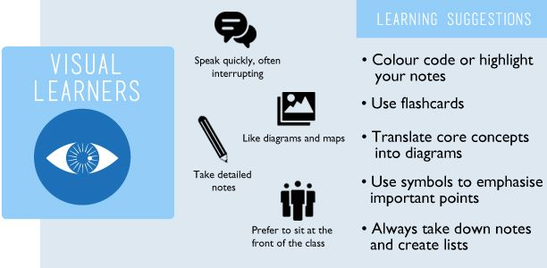

#### Other tests results

##### Brian’s test result:

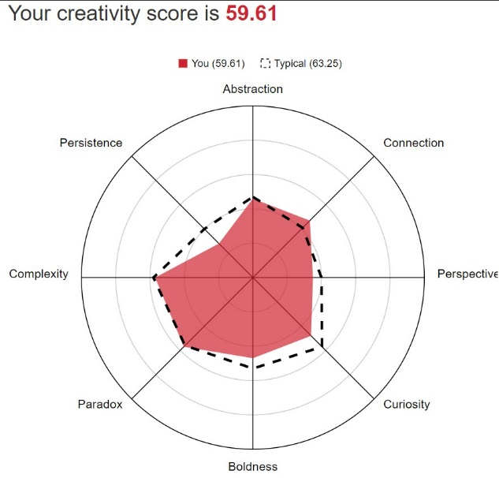

This test evaluates creativity. Working in a group on a project often requires a creative approach, so such tests can be useful in determining the strengths and weaknesses of a person. One of the strongest Brian’s creativity features is connection which means the ability to make connections between things that don't initially have an apparent connection. This feature will help to solve problems arising in the work on the project in an unusual way.

##### Jeremy’s test result:

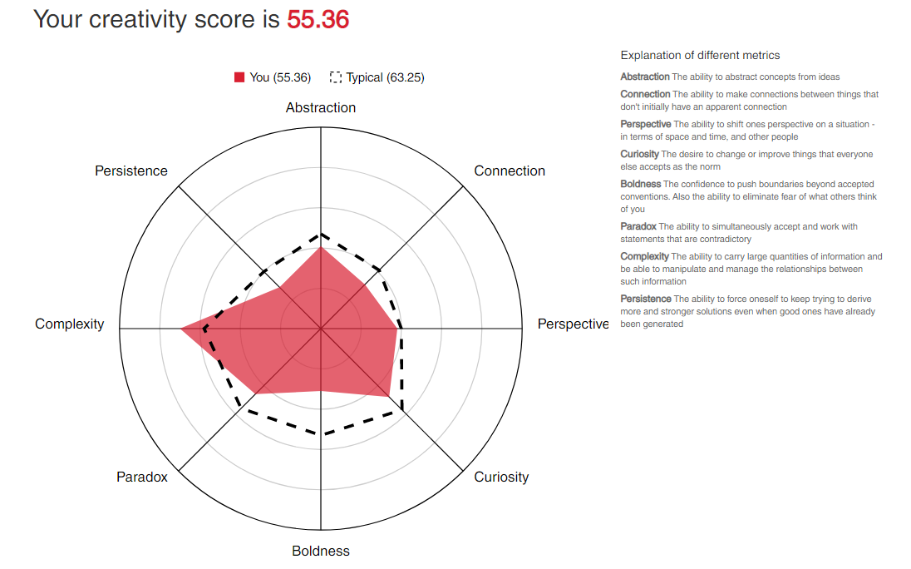

Jeremy has chosen the test on creativity too. His strongest feature is complexity - the ability to carry large quantities of information and be able to manipulate and manage relationships between such information. It will be incredibly useful in working with a big amount of text and information.

##### Shane’s test result:

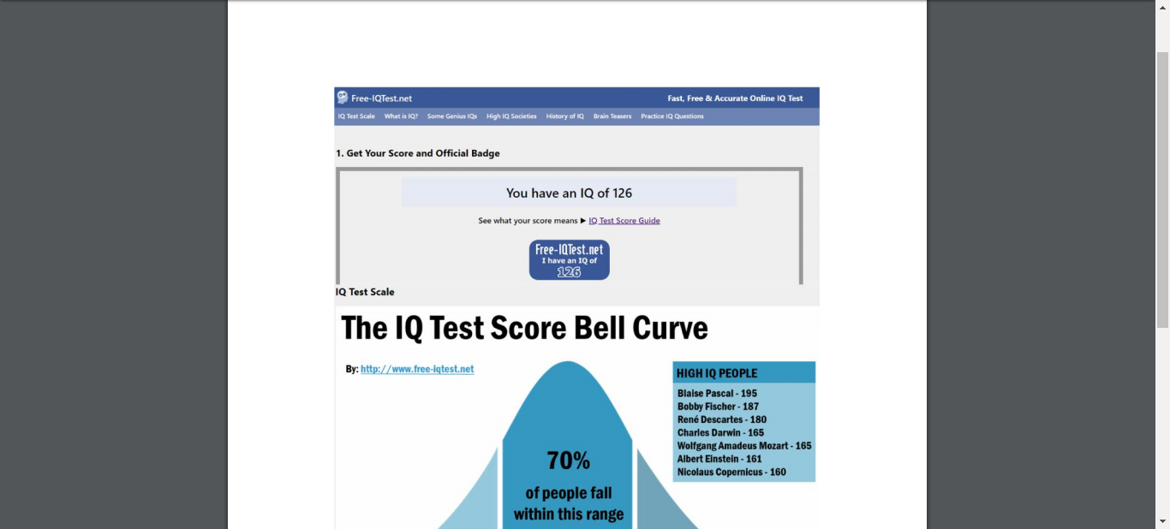

Shane has chosen IQ test. As he wrote in his Assignment 1 project, IQ test would not necessarily influence behaviour in a team environment. It would be more rational to draw conclusions based on abilities and personalities.

##### Daria’s test result:

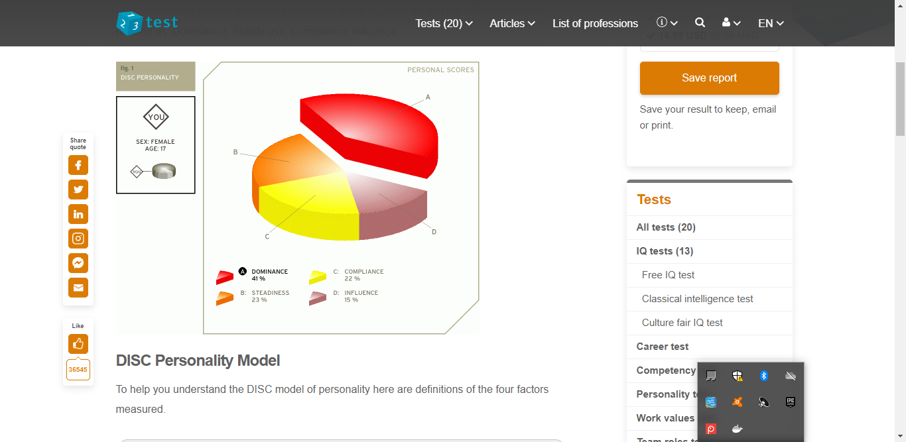

Daria has done the DISC test. Her result is dominance which means that she is responsible and likes changes and challenging tasks.

## Ideal Jobs

In this section we compare and contrast our ‘Ideal Job’ seeking common elements and exploring what differentiates one position from another.

All of us have chosen different positions to aspire to.

* Brian – Solution Architect.
* Daria – Machine Learning Engineer.
* Jeremy – Chief Information Officer.
* Shane - Principal Data Insights Analysist.

The table below highlights common skills, qualifications and experience across the four jobs.

| Position | Skills | Qualifications | Experience |
| --- | --- | --- | --- |
| Machine Learning Engineer | **Excellent Communication**  **Advanced Database Knowledge**  **Programming languages**  **Ability to analyse, model and interpret data.**  **Problem Solving** | **Degree or better in A technical discipline.** | Machine Learning  **Statistics Fundamentals**  Workflow Management Solutions  Specific machine learning packages  **Programming** |
| Chief Information Officer | **Excellent Communication**  People Management  **Project Management**  Stakeholder Management  Strategy and Business Planning  **Problem Solving** | **Degree or better in I.T. Discipline** | ICT Management  **Software applications**  **ICT and related Hardware**  **Cloud Computing** |
| Principal Data Insights Analyst | **Excellent Communication**  Excellent Problem Solving  **Database Scripting Languages**  **Ability to analyse, model and interpret data.**  A high level of mathematical ability.  **Problem Solving** | **Degree or better in I.T. Discipline** | **Business Analysis**  Data Analysis  **Statistics Fundamentals** |
| Solutions Architect | **Excellent Communication**  **Problem Solving**  **Project Management**  **Advanced Database Management**  **Knowledge of Programming Languages**  I.T. Architecture  Infrastructure Design | **Degree or better in I.T. Discipline** | **Software Applications**  **ICT and related Hardware**  **Programming**  **Cloud Computing**  Engineering and Software Architecture Design  **Business Analysis** |

##### In conclusion

While there are two common elements across the four positions

* Skillset - Excellent Communication
* Qualification – Degree or better in an I.T. Discipline

the positions are not so dissimilar, if the higher level technical aspects are removed.

The following would be useful across all positions.

* Business Analysis
* Knowledge of Cloud computing
* Project Management
* Problem Solving
* Workflow Management Solutions
* Data Analysis
* Extensive Knowledge of Software applications

## Tools

G6 Internet Explorers Team website:

<https://g6-internet-explorers.github.io/>

G6 Internet Explorers Team Repository:

<https://github.com/G6-Internet-Explorers/RMIT-Assignment-2>

The G6 Internet Explorers Team utilised Microsoft Teams available through our RMIT Office 365 account to manage online chat and communications. We also posted links to relevant videos and websites within the chat so as to provide context rather than uploading these to GitHub. Through this same platform we also trialled the use of OneNote and Microsoft planner, which we ended up not using to a great extent. Our Team meetings were held through zoom teleconferencing software which allowed us to discuss and contribute in real time as if we were in the same office. Zoom also allowed us to record the session, which allowed anyone not able to be present to catch up at a time that suited them. Zoom, while providing screen sharing capability also allowed for keyboard and mouse control to be switched to other team members during a meeting.

We do not believe the audit trail on the Git repository accurately reflects our individual contributions, as decisions to create or update folders and text or upload word and excel documents were often made and actioned during our teleconference Team meetings. As such the audit trail will show the username of the person hosting the teleconference rather than the team member who created the content. Additionally, with the problem of GitHub invitations apparently being blocked within RMIT email systems and subsequent delay in providing group access it is incorrect to attribute the initial flurry of activity to any one individual, as with appropriate access others would have contributed equally.

## Industry Data

In the following section we reflect on our ‘Ideal Jobs’, delve into the skillsets required and explore what demand there currently is from employers.

##### Job Titles

To gather accurate data for skill sets could not be truly accurate as each member chose a job advertisement from different sources and written by different companies. Government positions were more in-depth compared to private organizations. One advertisement in particular was very vague on the required skill sets required.

All four members of our group had different job titles. These are as follows:

Solutions Architect - Chief Information Officer - Machine Learning Engineer - Principal Data Insights Analysist.

When comparing these job titles from the Burning Glass Data, only one member of our team had their job title on the list. The title that matched on the list was Solution Architect.

##### Employer Demand

When searching using seek.com.au for the other titles and search criteria of Information and Communication Technologies, the following results were listed:

1. Solutions Architect, which rates as position number one on the Burning Glass Data, returned 938 positions.
2. Machine Learning Engineer = 190 positions
3. Chief Information Officer = 58 positions
4. Principal Data Insights Analysist = 1 position

##### Baseline Skills

* Excellent Communication Skills – Ranks #1
* Problem Solving Skills – Ranks # 2
* Analytical Skills – Ranks # 17
* Management Skills – Ranks # 19

##### I.T. Specific

* Business Analysis – Ranks # 9
* Customer Service – Ranks # 14
* Cloud Computing – Not Ranked.

The three highest ranked IT specific skills that are not in our groups required skillset are:

* SQL
* JavaScript
* Java

The three highest ranked general (baseline) skills which are not in our groups required skillset are:

* Organisational Skills
* Writing
* Team Work / Collaboration

##### Comments on Opinion of Original Ideal Job

Brian - The position of Solutions Architect has been an ambition of mine for many years and I have been fortunate to perform some of the tasks associated with the role in positions held in several companies. The particular ad referenced in my personal profile is fairly unique in that it is exactly what I wish to do, it was not chosen as an example of the kind of role I seek but the actual job I want.

Daria - Becoming Machine Learning Engineer is one of the main goals in my life and I am really passionate about it, so after looking at the data I would not change my dream job even though I do not possess any important skills such as Python, SQL or Java at the moment.

Jeremy - With the data given. I do not believe I would change my dream job, as I love to be one of the leaders re-shaping what I.T should be in organisations. Being a door that interconnects and facilitates this change as the IT industry itself begins change towards a very different look in the coming years.

Shane - I would not change my dream job based on the data because my dream job would be a job doing something that I am interested in and passionate about. Perhaps if I were younger and wishing to gain experience, I would reconsider to broaden my options to open more opportunities. In my current and also my dream job, the three highest skill sets in demand that I do not have are the top three, SQL, JavaScript, Java. In my dream job the three highest generic skill that are not listed are, Problem Solving, Organizational Skills and Writing. I do believe however that I do possess these skills.

## IT Work

The G6 Internet Explorers Team had the pleasure of interviewing Mr Tom Tighe Director of Operations – Payment Solutions - Shiji Group to obtain insights into what I.T. Professionals may face in the daily work.

#### What kind of work is done by the I.T. professional?

Tom, who is based in Sydney Australia, is responsible for the release and deployment of hospitality industry solutions globally. He manages a team of support and implementation technicians that deliver primarily, payment solutions to hotels, sporting stadiums, casino’s and the like. He has several staff with him in Sydney but most of his team is based in Atlanta in the U.S. His role also involves working with sales to develop new solutions based on customer requests, liaising with suppliers and vendors and dealing with clients and potential customers directly.

##### What kinds of people does the I.T. professional interact with? Are they other I.T. professionals, Clients?, Investors?, The general public.

In his role, Tom mainly deals with other I.T. professionals, CIO’s and I.T. Managers from client sites and potential customers as the business provides technical solutions to the market place, that they will have responsibility for. There is some interaction with Managers in Finance roles within these same organisations with the solutions primarily payment gateway focused. Other interactions are with internal Sales and Marketing teams.

Interestingly he mentioned the importance of networking with I.T. professionals particularly those in the same field or industry. He is a member of an organisation that meets irregularly, that provides a social environment to meet and engage with I.T. and Finance professionals that he may not normally encounter. Through these gatherings and the contacts made several business opportunities became available.

##### Where does the I.T. professional spend most of their time.

Currently the business is undergoing rapid expansion with new products being released to the market and additional clients coming on board. Most of Tom’s time is being spent on managing the release and deployment of the new software, that is ensuring the products work as expected, that any specific platform requirements and configurations are well documented and in planning and organising the implementation of the new products. Additionally being responsible for a team based in the United States that he does not see in the office on a daily basis, means he tends to focus more on their output and issues and generally keeping tabs on them than he would if they were Sydney based.

##### What aspect of their position is most challenging?

From the interview it was apparent that the greatest challenge was the diversity of technology found not just in the marketplace but also within his own organisation. One major client in the United States has a unique solution developed only three years ago that is not duplicated anywhere else in the world. It is so different to the other solutions provided, that support staff often struggle to understand and remedy issues. Fortunately, many of the developers who worked on the original project are still with the business and are called upon to provide assistance. Some clients are still running quite old technologies while new implementations are using AWS and other cloud based product. With the explosive growth of the business and release of new software this gap continues to widen. Legacy and more recent implementations have very different configurations, very different technologies and in some cases terminology which provides challenges for support and installation staff performing general support as well as impacting on any upgrades to the systems.

## IT Technologies

With many exciting and promising developments emerging in the world of technology, the G6 Internet Explorers Team chose to research and report on four that we thought would have a lasting impact and which interested us the most. The topics were Cybersecurity, Machine Learning, Autonomous Vehicles and Natural Language processing and Chatterbots. We are pleased to share our thoughts below.

### Cybersecurity

Since the birth of IT until today, we are all connected in one way or another with the internet in many ways. Even if we were born prior to the “digital age”, from when we are born our personal information is entered into a computer, when we first visit a doctor, when we get our driver’s license or an ID card, when we open a bank account and all the social media, shopping, web browsing history and emails in between that.  Our information is in what we commonly refer to as “Cyberspace”. Cyber being the prefix as anything related to something computer related, networks.

#### Cyberattacks!

Information is power and data creates information, therefore it would be true to say that all data is of high value and therefore vulnerable to attack for the purposes of theft, disruption or misuse. An organization or government network could come under attack for political issues or just to cause disruption/wreak virtual havoc or more commonly these days, financial gain and terrorism. Our own personal computer or devices can come under attack to gain personal or sensitive information about us or simply to knock out our system or information just to annoy us. All these attacks are commonly known as “Cyberattacks”.

#### What is Cybersecurity?

Cybersecurity is the practice of protecting ourselves from cyberattacks. Installing policies, security experts and software to monitor our networks, systems, software and data.

#### How does Cybersecurity affect us?

Our lives rely so much on technology now that technology effects the way we travel, the lights in our house and keeping the food in the refrigerator on. Our information is stored in databases all over the place; government departments, hospitals, banks, phone companies, real world and online stores, email accounts, online games and various other applications that we use for business and entertainment.  The traffic lights, the air traffic control at airports, the trains and even the garbage man relies on data to keep our lives running smoothly and safely. Our police and military have sensitive information and real time information systems to secure our way of life. Telecommunications to connect us together with phone calls, video calls, chats, emails and tweets just to name some of the services, not to mention linking all of us together via the internet.

We are constantly creating data even if we don’t know it by going about our normal daily lives, watching something on tv, reading a webpage, using GPS, searching something up on the internet or giving a thumbs up to a picture or video. A cyberattack at a personal level can leave us disconnected, our identity stolen, our personal information and memories lost. A cyberattack at a commercial level can ruin a company due to downtime, stock prices, customer lists, marketing or prototypes stolen, lower buyer or investor confidence. A cyberattack on a government level can mean personal information stolen on a massive scale. It could cause the shutdown of services such as health, transport and even effect the country’s currency rate. In a worst case scenario, foreign governments could even affect the politics of a country. A cyberattack on a police or military level could severely risk our security. Evidence tampering, witnesses and potential suspects safety, knowledge of police surveillance operations, identities of law enforcement personal. Potentially this could lead to a large variety of crimes committed and being unsolved. If our military intelligence was cyberattacked it would affect the safety of our peacekeepers and ultimately our countries security. A worst case scenario is we could theoretically be invaded or the intelligence leak cause a war.

#### Types of Cyberattacks

* Malware
* Ransomware
* Distributed denial of service (DDoS) attacks
* Spam and Phishing
* Social engineering

MALWARE – is a term used to describe malicious software or “fake software”. Normally this software is downloaded from the internet or via an email. The user may think they are opening an attachment or installing a useful application, but actually its fake software that gets installed usually in the background. This software can steal, delete or encrypt your data. (Malwarebytes)

RANSOMWARE – is a type of malware that encrypts data or denies access to a system until a ransom is paid. Ransoms are usually paid in untraceable cryptocurrency. Once payment is received a code is sent to the owner or technician of the system to enter in to regain full access. The most common way to be infected with ransomware is via a phishing email. (Department of Homeland Security, 2016)

SPAM and PHISHING – Where spam is widely known as “junk Mail”, email that is unsolicited or unwanted. Phishing however is a cleverer type of spam. The email will appear to be from a legitimate source. The email may have a format and logo of a legitimate company and sometimes may even be addressed to you personally by name or simply say G’day mate! The email may ask for a reply or give a link to a website that also looks legitimate and have a similar URL that we would expect. Unknowingly the receiver is reply to or entering in personal information to a fake source.

DDoS – Distributed denial of service (DDoS) attack is a cyberattack from multiple sources to compromise the computer system. Such attacks will normally have a specific target such as a server, email, online accounts such as banking, website or other network resource and flood it. This type of attack causes a “Denial Of Service” which means the legitimate user can be blocked out of their own system or their system could be forced to shut down. This can cost an organization quite a lot of time and money while they cannot provide service. (Rouse, 2019) (CISA, 2019)

SOCIAL ENGINEERING – in this scenario the attacker will find some personal information about their “target” and then will send them a phishing email with enough personal information in the email that the target would assume is a legitimate email. The target would likely give up more personal information or be taken to a phishing site that can steal their passwords, logon info and other personal information.

#### How did we get here and where are we going?

In the pre technology world our biggest fears might be that someone knew our unlisted phone number or broke into our home or office. In today’s technological world, information is power, and thieves are able to steal our information, our identities or even close down our businesses and we may not even know each other. Technology and reliance on the internet forces us to learn and adapt a whole new set of rules to live by and continuously upgrade our cyber protection.

#### Where is the technology going?

Since the early days of antivirus software such as “The Reaper” in the early 1970s, technology in this field has evolved to include physical devices such as the Zyxel “ZyWALL” firewall, a host of anti-malware such as Malwarebytes Antimalware to full antivirus and internet protection suites for personal devices, home and large enterprises such as Bitdefender Internet Security.

Kevin Skapinetz, IBM Security vice president of strategy and design, explains that cybersecurity is evolving as organizations cannot keep up with the advances in attack technology. Artificial intelligence is able to learn from current threats on the fly and calculate possible threat scenarios to a much greater extent than a human security analysist is able. That although artificial intelligence technology is not perfect yet, it continuously is learning and does not forget, allowing us to make more accurate decisions. (IBM, 2018)

#### Implementing Cybersecurity

Unfortunately, in cybersecurity there is not a one system fits all as cyberattacks can come from multiple platforms and levels. Having the best firewall will still not defend an organization if its staff are untrained or stringent policies are in place. Consider for example your home computer. If your firewall pops up a warning that a website is not safe, but you click “it’s ok” and continue anyway, then all the technology and cost involved in developing that software is not the be all and end all solution. A company might spend thousands of dollars on hardware, software and personal; but if an employee plugs in their USB stick that they have been using at the local café, this could also infect the company’s network.

### Machine Learning

#### Abstract

In the modern scientific space, people are going deep into the Artificial Intelligence research. This term means the ability of intelligent machines to perform creative functions that are traditionally considered as the prerogative of human beings. Disputes about the prospects and risks of its wider use are growing but there are no doubts that the Artificial Intelligence (AI) will significantly impact on our world. Machine learning is one of the areas of AI. Its basic principle is that machines receive data and “learn” from it. Unlike programs with manually encoded instructions for performing specific tasks, Machine Learning allows the system to learn how to independently recognize patterns and make predictions. That is what makes Machine Learning one of the most perspective Artificial Intelligence subsections.

#### The state of art of ML

Nowadays, there is a huge number of Machine Learning experiments. The development of this sphere is happening with an incredible speed and people find the use of Machine Learning in different life aspects. These are some examples of the latest researches:

“Aug 16, 2019

Scientists used machine learning to analyse the coevolution of physical traits in butterflies.

A machine learning algorithm revealed that coevolving butterflies “borrow” physical features from each other, such as wing shape and pattern, and use them to generate novel features over time, researchers reported August 14 in Science Advances. The scientists set out to test a model known as Müllerian mimicry, which proposes that species sometimes mimic each other to glean mutual benefits.”

“Machine learning could be the key to reducing the use of animals in experiments.”

“We showed that artificial intelligence (AI) could mine existing data on chemical toxicity and generate new information...The software takes advantage of the power of big data and transfer learning, a machine learning method that applies information from one task or set of items to another.”

There are much more interesting areas where Machine Learning and Artificial Intelligence are used now. We meet some of them in our day to day life. Virtual Personal Assistants, Search Engine Result Refining and even Product Recommendations are useful to many people which sometimes do not know that these applications are of Machine Learning. However, Artificial Intelligence is also in demand in more significant projects. For example, Machine Learning can predict illnesses or population health risk by revealing patterns and markers of high risk. And what is more, one of the primary clinical applications of Machine Learning lies in early-stage drug discovery process as it can process the data that has been collected over many years and sometime decades in very little time. Also, Artificial Intelligence allows government agencies to identify ways of increasing efficiency and save money. All in all, Machine Learning has a huge impact in the modern world. (340)

#### The nearest future of Machine Learning

Machine Learning will have a huge impact on medicine even in a couple years. Numerous researchers are underway on the use of AI to diagnose various diseases, such as cancer. An Artificial Intelligence program called a Neural Network was created this year. It can detect lung cancer with 94 percent accuracy.

“These people have a technology that will improve the precision of screening tremendously,” Otis Brawley, an oncologist and epidemiologist at Johns Hopkins University.

At the moment, the program may issue erroneous diagnoses that is why it needs to be improved. However, in the next three years, similar programs will already take effect and diagnose cancer and other diseases in many countries.

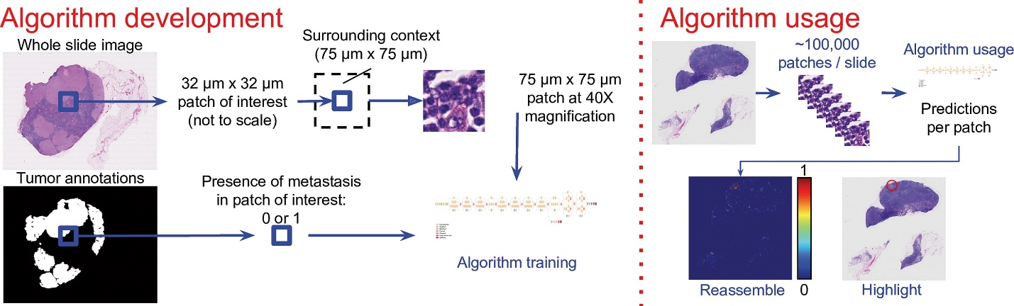

The use of AI and Machine Learning is not just about medicine. They are also able to assist us in developing a healthier relationship to social media.

“Kane’s opinion is that AI can take this same data and provide insightful analyses of what it portends for our overall well-being, mitigating social media’s addictive elements… Kane is therefore suggesting AI could be deployed as a countermeasure. Using its ability to synthesize vast data streams, it could offer a different feedback loop, promising healthier outcomes.”

##### Technological development that makes it possible:

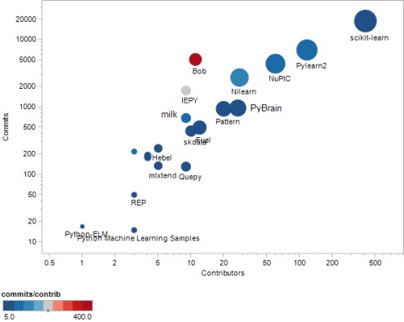

Overall, ML is heading to transform medicine, science, social media and many others aspects of our life.

#### The likely impact

As a result of Machine Learning progress, diagnosis of certain diseases will become automated in many developed countries. Programs which contains a huge amount of information about diseases and their symptoms will be able to determine the diagnosis in the accurate and effective way. Cancer is among the leading causes of death worldwide. In 2012, there were 14.1 million new cases and 8.2 million cancer-related deaths worldwide. Usually it is due to too late detection of the disease and diagnosis.

Artificial Intelligence programs which can establish an accurate diagnosis in the early stages will completely change this deplorable situation. Mortality from cancer and other diseases will decrease, as it will be revealed when there is still a greater chance of saving a life. This development will have a huge impact on people with cancer and since the number of them is growing every year, creating such programs is very important.

Such technologies will not be able to replace any professions in the next three years, at the same time, they can improve the working process of radiologists. For example, a great low-level Julia deep learning package, to build the models to identify reference cases for physicians.

“While radiologists spend up to 20 minutes searching for information, context flow using Julia promises to cut down search time to ~2 seconds. Taking into account a global shortage of radiologists, this could be a real solution.”

Another significant ML development of the future is AI assistant in building healthy relationships to social media. Despite the fact that it is not going to fight with global problems, its impact on our day-to-day life will be noticeable.

More than 3 billion people actively use Facebook, Instagram, YouTube and other platforms, leading to an average daily usage of nearly 2.5 hours. These statistics drastically increase when it comes to the younger demographic.

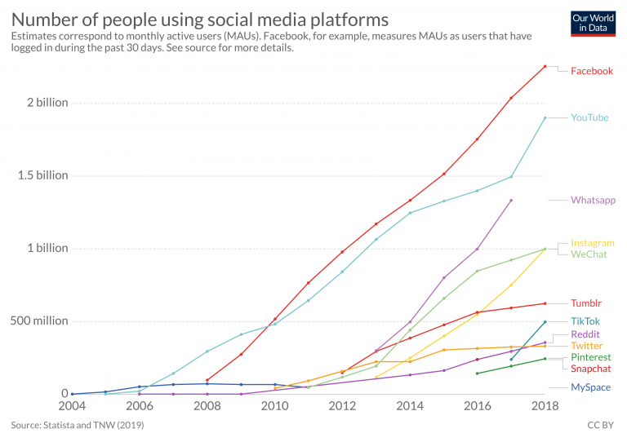

ML can help many people cope with Internet addiction. Not only can the technology provide information on its impact to our overall health, it can also offer suggestions as to how to improve our behavior.

“People sometimes need to be scared into action. We all look at our mobile devices and our computers on a daily basis and see a large number on the screen. But what does that tangibly mean to our overall happiness?” - growth strategist Brendan Kane

As a young person, I spend a lot of time in social media. Therefore, such development can strongly affect me. Sometimes I do not think about how much time I waste on unnecessary things. That is why it is so helpful to remind me about this. Due to ML, it is possible to spend less time on the Internet and this will improve my health and quality of life. Many people, like me, will have more time for self-development and hobbies.

My family and social circle are also full of internet addicts. For example, my younger sister spends more than 9 hours a day on social media. By assessing the big picture, AI assistant can help her more consciously use social media.

In conclusion, having understood the state of Machine Learning and its possible impact on our future, you begin to realize how much of our life it covers.

### Autonomous Vehicles

Autonomous Vehicles is the automated process of piloting vehicle using artificial intelligence instead of a person. The state-of-the-art technology of automated vehicles is the implementation of self-driving cars, buses and trucks in society made possible from Machine Learning. Machine learning is the ability for A.I to receive data and be able to make informed decision from the information it has received. This can be done through observational data or from specific instructions given by a developer. (Team, 2017)

Currently machine learning is partially seen through the integration of built-in technologies within vehicles, which have APIs allowing for links to be made with outside hardware such as, the vehicle outputting audio from the mobile phone music playlist. Other methods can be expressed through the use of a camera detector analysing field depth when calculating the distance between the rear of the car and vehicle spot end while reversing.

As processors are advancing with their architecture, they are becoming smaller and more efficient. A rise with machine learning technology will be seen to become more powerful in its complexity to handle multiple inputs from various sources. This can be seen with the advancement in research and development from major brands such as Intel or Nvidia. It will boast to be a major leap forward for autonomous vehicles function in all of society. (Nvidia, 2020) - (Intel, 2020)

In the general society this allows a major change in areas such as civilian cars and taxis. For civilians it would drastically change how safety operates in each vehicle. Allowing for a reduction in vehicle related accidents for example if a driver is not driving properly it can forcibly take over from the driver and immediately correct any movements, which may cause harm for the person or other drivers. Also, when a driver is speeding, a safety measure can be put in place to have the vehicle reduce speed to match current speed limits.

On the other hand, since the progression of electric cars is becoming more prominent as a cleaner alternative to petroleum. We will start to see an incredible impact in technological efficiency leading to far less use of carbon emissions in motor vehicles. This can be also said for electric vehicles resulting in autonomous vehicles leveraging this advancement in efficiency to reduce carbon emissions and be hopefully brought in as a new standard.

For the transportation industry we can see self-driving trucks able to carry large payloads and meet deadlines at a more efficient time than relying on a driver needing regular breaks. This can increase productivity and lower risk within the commercial industry, as it reduces transportation time and the product is kept in the best condition when the delivery has been made. This can be both in between the warehouse or retail store, and retail store to the customer. Ultimately increasing efficiency for companies to earn a bigger profit for less overhead costs.

In 5 more years, we should start to see autonomous vehicles becoming more common for the average person. Whether it be catching the bus, driving to work or receiving parcels from an online order, no doubt autonomous vehicles will have a much stronger presence in day to day activities.

#### Likely Impact

As technology advances and the integration of machine learning gives rise to more automated vehicles, the main concern we will run into is the ethical logistics behind the decision-making process for all autonomous vehicles. What will the vehicle deem as the right decision and how can we trust in an object to make the most ethical decision in unexpected situations? These decisions could be pulled from observational data, but then the real questions come into play, how can an autonomous vehicle make critical decisions in situations it has never observed? This will bring about a major impact of safety concerns on the general residential population. A few of these concerns may include, vehicular control, security and integration.

Security is an issue where hacking can be seen to occur often every day without anyone realising it has happened. With technology being more integrated with our daily lives and households, it can prove to show another gateway for hackers to use autonomous vehicles for breaching household security. Using credentials that are either saved on to a mobile device or vehicle to gain access into personal information. Allowing for identity theft or quite possible control the household to further gain security access into areas restricted to the public. For example, a breach in security can be made if the hacker is aware of an individual who holds a high status whether it be in a company or in the government sector. To gather credentials of the individual using the autonomous vehicle to breach the persons home, or if the vehicle is owned by the organisation to then breach security protocols and gain further access.

Lastly, the job landscape will shift where taxi drivers, bus drivers, truck drivers and possibly other industrial vehicular facilities will no longer be required, as A.I will take over the job. Leading to people working their whole lives for that particular role to be made redundant. There will be a rise in unemployment, however a rise in more expertise roles requiring a person to fill. We will start to see this change further develop into education and the shift will push the next generation to fill in the expertise gap to maintain the change in industry. This impact will take at least 10 years in order to realise but jeopardize current people’s livelihood who currently work in the transportation industry or general commercial industry who operate such vehicles.

#### Affects

I believe on a personal level it will improve my savings when travelling to where I need to go and saving my time. When Autonomous vehicles have reached efficiency in its decision making it will lead to two avenues reducing in cost and effectiveness. One will be in petrol consumption and the other will be in travelling time. When more vehicles have moved across into automation then it will allow for a synchronisation net to be established for vehicles to smoothly transition to their destination, linking with other vehicles to co-operate in this vehicular flow. The A.I will also add to this by setting up a driving plan and calculate the appropriate speed and stops for the vehicle to function in peak effectiveness and efficiency for the driver to arrive at the destination at a respectable time. This will be based upon speed limitations and vehicle maintenance.

While there are concerns for security and the potential attack on the A.I function controlling major core systems of the vehicle. The bottom line of this is the ethical proportions of having an autonomous vehicle running on the road and having the A.I component decide what is the right decision to make. This decision-making process can be influenced by a hacker who can input wrong information into the processing component or lead to controlling the vehicle external, bypassing the need for a driver to be present in the vehicle. I feel this is a major concern in my personal life where I do not want some random person manipulating critical systems of the autonomous vehicle, which could inflict damage to me or my family.

The same goes for my family members who may take the vehicle on a trip or simply going grocery shopping. Knowing that the autonomous vehicle is not completely secure is a concern that would linger in my mind.

### Natural Language processing and chatterbots

Natural Language Processing, also known as NLP, is the science behind developing systems that allow a computer to have a meaningful conversation with a person using natural language. Natural language in this context means English, Chinese, Spanish etc. languages that are used in normal interactions between peoples of the world. The conversations may be verbal or textual, however voice must be converted to text for it to be passed through software processes and be understood by machines. Common use examples of NLP technology are Apple’s Siri, Microsoft’s Cortana or Amazon’s Alexa, which may be described as conversational agents, virtual assistants or chatbots and have found widespread acceptance and use in our everyday lives through our mobile devices and connected homes. This technology is being embraced in growing numbers by commerce as a basic customer service agent.

The current state of this technology may be likened to a child just starting to crawl. Although there have been significant advances in the last decade, NLP is still a young technology. These advances have been made possible using Artificial Intelligence and deep learning which has allowed conversational agents to become more lifelike and provide more sophisticated responses. Access to rudimentary chatbots for businesses is very easy, with numerous companies offering templated interaction for sales, support, surveys, recruitment and learning, which can be added to a website or social media in hours, with no need for coding.

Today, many interactions we have with organisations and government departments are initially handled by Artificial Intelligence and chatbots. These can handle increasingly complex queries to completion or transfer to a human agent for more detailed assistance. As may be seen from Figure 1 below, people expect that their likely chatbot interaction will be for basic questions and answers.

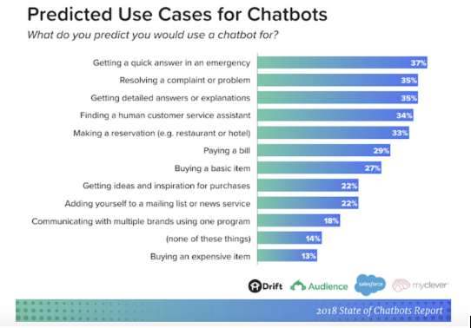

Figure 1(*Potential-Benefits-of-Chatbots-in-2018.png (698×442)*, no date)

Interestingly from Figure 1 is the percentage wanting a quick answer in an emergency. Given the disastrous bushfires currently sweeping Australia and the noticeable increase in tropical cyclone intensity over recent years, governments and councils will likely turn to chatbots and NLP as a way of ramping up the abilities of a call centre at times of crisis without having to provide the additional manpower.

Education is also adopting NLP technology, with chatbots available as course assistants or tutors which can assist each student individually, on their own device and at a pace most suitable to the student, providing there is access to the internet. Students can access assistance at any time of the day or night that best suits them, making it easier to study for many people whose work or other commitments make studying at regular hours a difficult proposition. Language learning is another area of education that is taking up chatbots as teachers and conversation partners, providing live conversations to students to improve their vocabulary. (*Will Chatbots Revolutionise Education?*, 2017)

IBM estimate that savings of up to 30% of the nearly $1.3 trillion, businesses spend on addressing customer requests can be made by going fully automated. (*11 Chatbots Trends to Help Grow Your Business in 2019*, 2018)

This significant amount of money will, drive ongoing research and development in NLU or Natural Language Understanding, the aspect of NLP that tries to understand and interpret the input text, extracting relevant information, and perform a variety of decisions based on its understanding. Humans have been conversing with one another for thousands of years and during this time have built up a knowledge of sentence structure, word meanings, nuances, grammar, context etc. Advances in artificial intelligence and deep learning algorithms will progressively develop proficiency in identifying and comprehending words and phrases improving the experience of dealing with a chatbot and their ability to provide increasingly complex responses.

#### Likely Impact

Other than an increased use of chatbots for Retail, HR, Real Estate, Finance, I.T. Support and Customer Services there are projects underway in healthcare that have considerable potential to impact society in a very positive way. One such open source project is a verbal conversational companion for dementia patients which besides being ‘someone to talk to’ aims to identify deviations of conversations that may suggest a degradation of memory function and as such alert carers and medical staff. Another medical related project is a verbal conversation agent called MedWhat which uses sophisticated machine learning to provide increasingly accurate responses to medical questions. (10 of the Most Innovative Chatbots on the Web | WordStream, no date)

Unstructured data such as social media posts, blogs, and news articles and interviews are being devoured by NLP and AI systems to improve comprehension, make the data more meaningful and enrich the ability for systems to interact “Naturally”. Furthermore, with access to big data, NLP will provide extensive business intelligence from raw data. One example is businesses protecting their brand image by using NLP to identify any negative comments or trends published online, anywhere in the world and allowing the business to intervene.

With NLP becoming smarter, virtual assistants becoming easier to work with and the hectic pace of life making us time poor, we will see increasing adoption of the technology in the home, our cars and in business. Being on hold for 30 minutes or more with a service provider, with that annoying message “you are number 501 in the cue” will be a thing of the past as during peak demand more chatbot instances can be spun up. Standing in the kitchen, trying to remember the best temperature for roast potato’s, will be a thing of the past when you just have to say “Hey Google”.

The impact of advances in NLP technologies will be most felt by peoples of the developed world as they have more ready access to devices and the internet. They will see a change in the way they interact with technology, with friends and family and with businesses, health services and government, as the prevalence of virtual assistants and chatbots, driven by NLP expands.

As the technology matures, call centre employees, receptionists, and sales people may find their positions redundant or their hours reduced with chatbots able to answer the majority of typical enquiries. Recruitment agencies will use NLP increasingly for candidate matching and resume pairing. Chatbots can schedule appointments and deliver job descriptions. Chatbots can work 7 days a week 24 hours a day, with no holidays or sick leave, and live by the millions on servers in the cloud.

Software engineers and data scientists familiar with NLP and chatbots should find an increase in opportunities.

#### Affects

As mentioned in the preceding text our daily lives will be affected by NLP and associated technologies in significant and sometimes subtle ways. Our own household has recently acquired a connected speaker and we are still exploring all the ways it can enhance our lives. From finding the right playlist of music, to connecting with family and friends through voice calls. Of course, we can already do this with our smartphones but here is another gadget that may mean we don’t have to go looking for our phone. I expect it will not be too long before I can ask my preferred virtual assist to give me an update for the day and receive reminders about anniversaries, birthdays, bills falling due and any medical or other appointments, as well as the top news stories. I do very much look forward to being able to just dictate my correspondence and university work without the need to bash away at a keyboard. That will be a joy.

Precious time will be saved to be able to devote to hobbies, sports, walking, entertainment and study. At least that would be the intent, there is a learning curve to acquiring and exploiting any new technology and our little Google Nest Mini has been an exercise in frustration. Before individuals, homes and businesses can fully embrace NLP and associated automation there is the very real need for fast and reliable internet connectivity. Living as we do in a large regional centre, we find it harder than friends and family in the large cities to obtain access to reliable internet. Some family and friends in more rural areas struggle just to get a decent mobile phone signal, so the rates of adoption and the uses they are able to put the emerging technologies to will vary significantly.

## Project Ideas

## G6 Internet Explorers Group Project

#### Overview

With Cyclones becoming more powerful and bushfires spreading with unprecedented speed and ferocity, the communities need for each and every one of us to have individual evacuation plans is crucial. Governments of all levels, banks and insurance companies create generic checklists and place them on their websites to provide a reference point. Some of these checklists may be used as templates to personalise the information.

Our group project idea is to create a chatbot that individuals and families can interact with, to build a complete personalised emergency plan, which can then be emailed back to the individual or family to be available should an event occur.

Local councils and state governments could place this chatbot on relevant webpages or in social media and the technology could allow for push notifications to registered people in the event of an emergency. The chatbot would also be aware if someone had started but not completed their checklist and prompt for it to be updated ahead of an event.

#### Description

While chatbots are being used to provide information and warnings in the event of an emergency, our idea is to deliver something like an individual consultation to assist in planning ahead of time. The chatbot, through a series of questions and responses will develop a picture of the usual physical locations of the individual or family and draw attention to potential issues such as presumable road closures due to flooding or bushfires. Should someone live in an area that is likely to be cut off the chatbot could suggest alternative routes or the need to consider evacuation earlier. Similarly based on the family composition it may offer suggestions as to foodstuffs and grocery items that should be stockpiled ahead of the season or when the emergency is still developing. While not a priority for the initial version a future update could harness existing ecommerce technology to place an order and have delivered these items, in locations where this is available reducing the perceived inconvenience of shopping for the emergency larder.

#### Tools and Technologies

The technology and tools are currently readily available, both as open source and commercial options so there is no need to re-invent the wheel. The challenge for this project really is to come up with appropriate templates for the questions and answers, a process to harness localised geographical information and for a suitable front end to make it easy for governments and agencies to customise the process.

#### Skills Required

As mentioned above the software and technology is readily available and there is no need for special hardware. The current bushfire crisis in Australia that has touched so many areas and people, which has impacted a wider region than our worst tropical cyclone, has caused a great outpouring of generosity from peoples and businesses. It is believed that any specialist skills required for the project will be able to be procured readily from the broad community and business.

#### Funding

It is reasonable to assume that such a public interest and safeguarding project will be able to attract government funding or grants for any required project costs. Each local council would need to fund or seek funds to customise the solution to their local area.

#### Outcome

Once deployed and with a public awareness campaign this project will deliver an ability for individuals and families to better plan and be better prepared for natural disasters, which will improve the safety and wellbeing of the community, minimise stress by encouraging early planning and co-ordination and reduce calls to emergency services and other agencies. Whilst the nature of the emergencies may be different in disparate geographical locations the model could be adapted for any region of the world that has access to reliable internet.

## Group Reflection

In this Group Reflection section, each member offers some personal thoughts on our experience in group work and team building. We then offer a group perspective.

**Brian Dean**

I believe this group is outstanding, having come together fairly organically by placing our names in an available group rather than scouting around looking for people of like interests or in the same town or city. It is our diversity that allows us to present interesting and unique points of view. We have worked well together on common goals. As is evident by the differences in our ideal jobs and the blend of personality types we each bring unique experiences both life and employment to enrich the team. I believe our team meetings via teleconference were particularly effective as it afforded our geographically dispersed team the same access to live conversation that students studying on campus would have. For the next project I will recommend different project management tools as I underwent some frustration, with Microsoft Teams and the addons, with getting a clear picture of where we were at. One thing that did surprise me was the absolute absence of any conflict. The entire team were at all times respectful of each others ideas and opinions and sought through dialogue to form a consensus on the best approach to move forward. I have rarely found this in commercial enterprises. One thing I have learned about groups is that sometimes you can be really really lucky.

I look forward to working with all my new ‘mates’ on the next team project.

**Daria Sukonnova**

I really enjoyed working with everybody in this team. All members of my group are very understanding and friendly people who are easy to negotiate with. There were no problems with setting time for conferences, despite the fact that we live in different time zones. I also think that our group did a great job using the Github. Due to the good organization, it was easy to distribute the work among the team members.

I was surprised by apps that our group used for organization and chat. They were really.

Working as a team, I learned that it is essential to be able to express my thoughts freely about different aspects of the project and to be tolerant and respectful to everybody cause these things are significant for successful teamwork.

**Jeremy Naupay**

I have quite enjoyed the team work this group has shown. Seeing everyone in the group being open to their own project ideas and ideas on presentation have been amazing to witness. I have been amazed at everyone’s availabilities and willingness to contribute new ideas. I was surprised with everyone’s involvement even though we all live far from each other. Getting to understand the journey each group member has been on to get to this point has been very interesting. Being in a group has opened me up to different perspectives within the I.T industry. Allowing me to expand my knowledge base and develop my skillset with team work. I believe we can improve with a better project management system, as GitHub has helped in collating our information to a certain degree. It has not proved to be very useful with communication in the collaboration process. We did use Microsoft Teams to improve on communication within the team, but seem to have its own limitations with how posts are organised. Otherwise, working with this group has been an enjoyable experience and I look forward to working with such a good bunch of people in the future.

**Shane Thacker**

As this is my first time to work with an online team for study purposes, so I was quite sceptical and nervous at first that it would quickly deteriorate. I was quite concerned that other students very quickly made teams from the get-go, and I didn’t have a team.

Our team, “The G6 Internet Explorers”, came together quite naturally. We are all from different cities and half of us in different countries. None of us is an expert or had much to do with GitHub, so it was a group learning experience. We found common ground using tools that we are familiar with such as Microsoft Teams and uploading Ms Documents such as word and excel. As we developed our skills, we were “brave” enough to edit singular text files on GitHub.

Even with time zone differences, we managed to all get together weekly then biweekly and every other day towards the end of the assignment. Although our team did not nominate a leader, one member was very helpful in starting the GitHub and Teams site and hosting the meetings. During the meetings, all members were quick to volunteer for tasks and I feel they were distributed evenly by agreeing with each other rather than being delegated.

I have enjoyed working with my team and hope to work with them again in the future and catch up for a drink one of these days. I wish them al the best with their studies and careers.

At the end of the assignment, all G6 Internet Explorer team members met via web conference and discussed and agreed upon the following points collectively.

##### What went well

Overall everyone in the group agrees that communications went very well. All team members acknowledged the fact that each other lived in different time zones, but cooperatively we were all able to come together on a regular basis to collaborate. G6 Internet Explorer members all quote that they enjoyed working with each other and recognised that.

##### What could be improved

Our working knowledge of GitHub will need to be expanded as the process of creating a text file which GitHub can version and then cutting and pasting into word which GitHub cannot version duplicates effort and wastes time.

A different project management tool such as Trello would have allowed us to be better organised and have clearer defined milestones and deadlines.

##### At least one thing that was surprising

What surprised us all the most was the fact that all the members of our team were composed of total strangers and we manage to work together effectively. Our web conferencing sessions were genuinely useful and flowed smoothly, allowing opportunities for each member to contribute. We were surprised that everyone had the same expectations and made a genuine effort for the assignment.

##### At least one thing that you have learned about groups

Everyone in G6 Internet Explorers commonly agrees that we have learnt that working within a team, composed of complete strangers, is not as intimidating as we first expected.

Upon discussing each other’s reflections, that for teams to be effective, the correct tools are essential. If it was not for our group texting platform (Ms Teams) and the web conferencing platform (Zoom), there would have been significant breakdowns in our communications and difficulty in expressing our individual opinions.

All of us agree that we can take from this experience that we have developed new skillsets, mainly communication, that are not only essential for working within the Information Technology industry, but also for any business or study environment.

We all learnt that even with our limited experience using GitHub, that the science and method of  the application in regards to version tracking and the ability for a team to work on the same project, no matter their location, would be beneficial if not essential for the IT industry.

# References

*10 of the Most Innovative Chatbots on the Web | WordStream* (no date). Available at: <https://www.wordstream.com/blog/ws/2017/10/04/chatbots> (Accessed: 30 December 2019).

*11 Chatbots Trends to Help Grow Your Business in 2019* (2018) *Acquire*. Available at: <https://acquire.io/blog/chatbots-trends/> (Accessed: 30 December 2019).

*AI Accurately Detects Lung Cancer in Scans* (no date) *The Scientist Magazine®*. Available at: <https://www.the-scientist.com/news-opinion/ai-accurately-detects-lung-cancer-in-scans-65914> (Accessed: 11 January 2020).

Career FAQs. Unlock your learning style [Online]. Available at:

<https://www.pinterest.ru/pin/822892163146640731/>

Crystal. (2019) Personality Hub [Online]. Available at:

<https://www.crystalknows.com/personalities>

Free-IQTest.net. (2020) The Free IQ Test [Online]. Available at:

<http://www.free-iqtest.net/>

*Free online creativity test - TestMyCreativity* (no date). Available at: <http://www.testmycreativity.com/> (Accessed: 3 January 2020).

*hyperCODEmia* (no date) *YouTube*. Available at: <https://www.youtube.com/channel/UC8YaQYKffQkBc7-_uUUY-rA> (Accessed: 11 January 2020).

*Image of the Day: ButterflyNet* (no date) *The Scientist Magazine®*. Available at: <https://www.the-scientist.com/image-of-the-day/image-of-the-day--butterflynet-66280> (Accessed: 11 January 2020).

Intel 2020, Autonomous Cars You Can Trust, Intel, viewed 4 January 2020, <<https://www.intel.com.au/content/www/au/en/automotive/autonomous-vehicles.html>>

Kharkovyna, O. (2019) *Artificial Intelligence & Deep Learning for Medical Diagnosis*, *Medium*. Available at: <https://towardsdatascience.com/artificial-intelligence-deep-learning-for-medical-diagnosis-9561f7a4e5f> (Accessed: 11 January 2020).

Liu, Y. *et al.* (2018) ‘Artificial Intelligence–Based Breast Cancer Nodal Metastasis Detection: Insights Into the Black Box for Pathologists’, *Archives of Pathology & Laboratory Medicine*, 143(7), pp. 859–868. doi: [10.5858/arpa.2018-0147-OA](https://doi.org/10.5858/arpa.2018-0147-OA).

Nvidia 2020, Self-Driving Cars, Nvidia, viewed 4 January 2020, <<https://www.nvidia.com/en-au/self-driving-cars/>>

*Opinion: AI Beats Animal Testing at Finding Toxic Chemicals* (no date) *The Scientist Magazine®*. Available at: <https://www.the-scientist.com/critic-at-large/opinion--ai-beats-animal-testing-at-finding-toxic-chemicals-65795> (Accessed: 11 January 2020).

Pennsylvania Higher Education Assistance Agency. (2019) Education Planner [Online]. Available at:

<http://www.educationplanner.org/students/self-assessments/learning-styles-quiz.shtml?event=results&A=7&V=10&T=3>

*Potential-Benefits-of-Chatbots-in-2018.png (698×442)* (no date). Available at: <https://www.digitalmarketingcommunity.com/wp-content/uploads/2018/11/Potential-Benefits-of-Chatbots-in-2018.png> (Accessed: 9 January 2020).

*Ransomware | CISA* (no date). Available at: <https://www.us-cert.gov/Ransomware> (Accessed: 6 January 2020).

Sidoruk. Cognitive Functions [Online]. Available at: <https://www.pinterest.pt/pin/839358449275858166/>

Sahota, N. (no date) *A.I. Will Soon Transform Social Media; The Question is How?*, *Forbes*. Available at: <https://www.forbes.com/sites/cognitiveworld/2019/07/03/a-i-will-soon-transform-social-media-the-question-is-how/> (Accessed: 11 January 2020).

Team, E. S. (2017) ‘What is Machine Learning? A definition’, *Expert System*, 6 March. Available at: <https://expertsystem.com/machine-learning-definition/> (Accessed: 31 December 2019).

*The rise of social media* (no date) *Our World in Data*. Available at: <https://ourworldindata.org/rise-of-social-media> (Accessed: 11 January 2020).

*The rise of social media - Our World in Data* (no date). Available at: <https://ourworldindata.org/rise-of-social-media> (Accessed: 11 January 2020).

*Understanding Denial-of-Service Attacks | CISA* (no date). Available at: <https://www.us-cert.gov/ncas/tips/ST04-015> (Accessed: 6 January 2020).

*What is a DDoS Attack (Distributed Denial of Service Attack)?* (no date) *SearchSecurity*. Available at: <https://searchsecurity.techtarget.com/definition/distributed-denial-of-service-attack> (Accessed: 6 January 2020).

*What is Malware?* (no date) *Malwarebytes*. Available at: <https://www.malwarebytes.com/malware/> (Accessed: 6 January 2020).

*Will Chatbots Revolutionise Education?* (2017) *InformED*. Available at: <https://www.opencolleges.edu.au/informed/features/will-chatbots-revolutionise-education/> (Accessed: 6 January 2020).